

PINE

Quotation # {{quote_number}}

For: {{customer_name}}

Date: {{quote_date}}
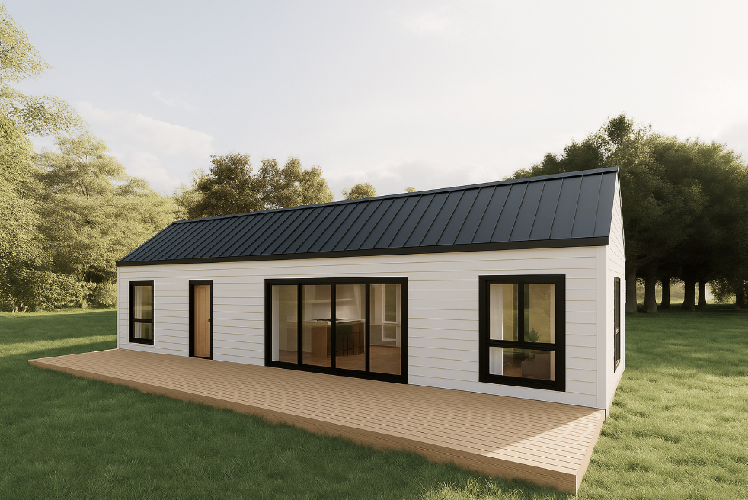


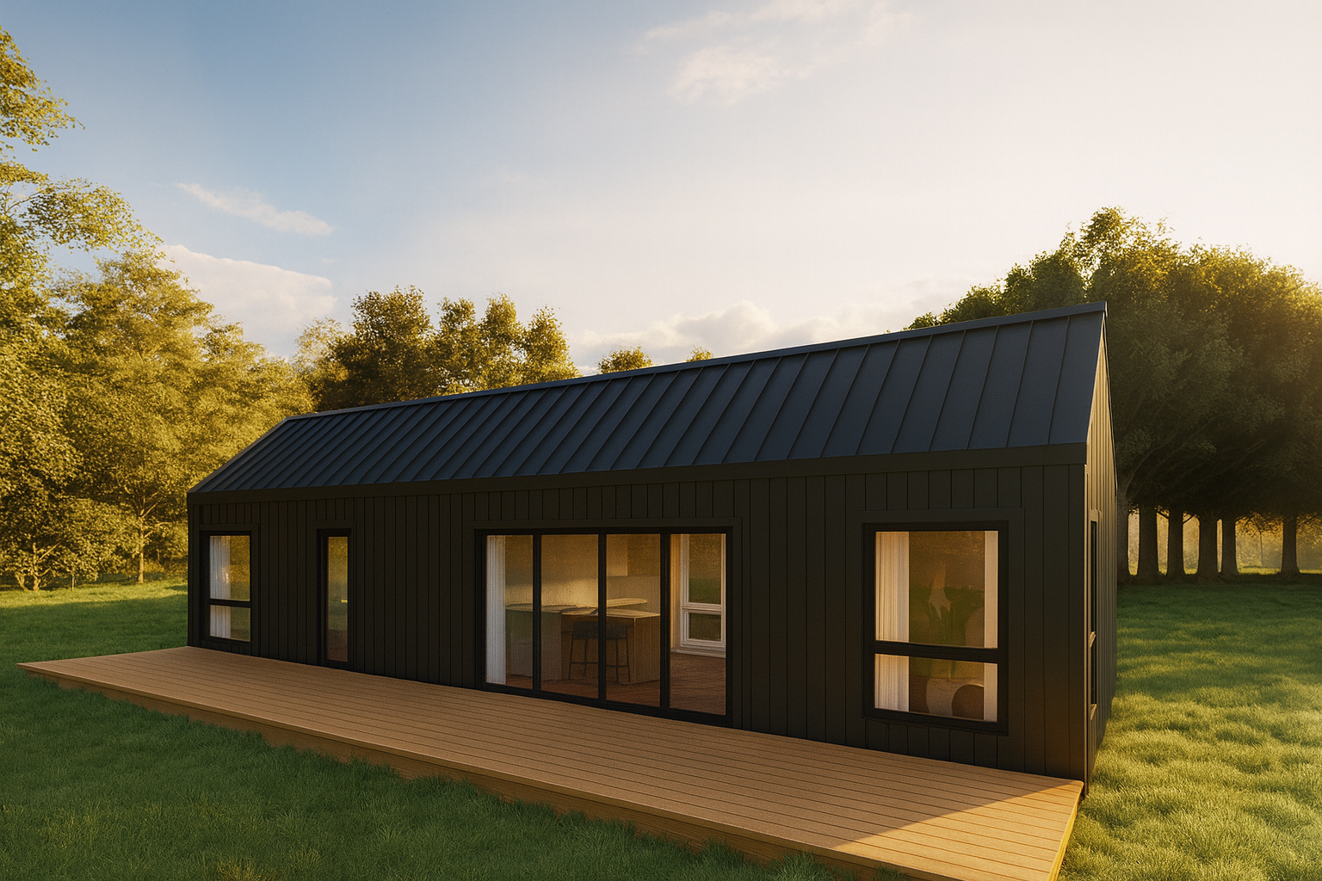

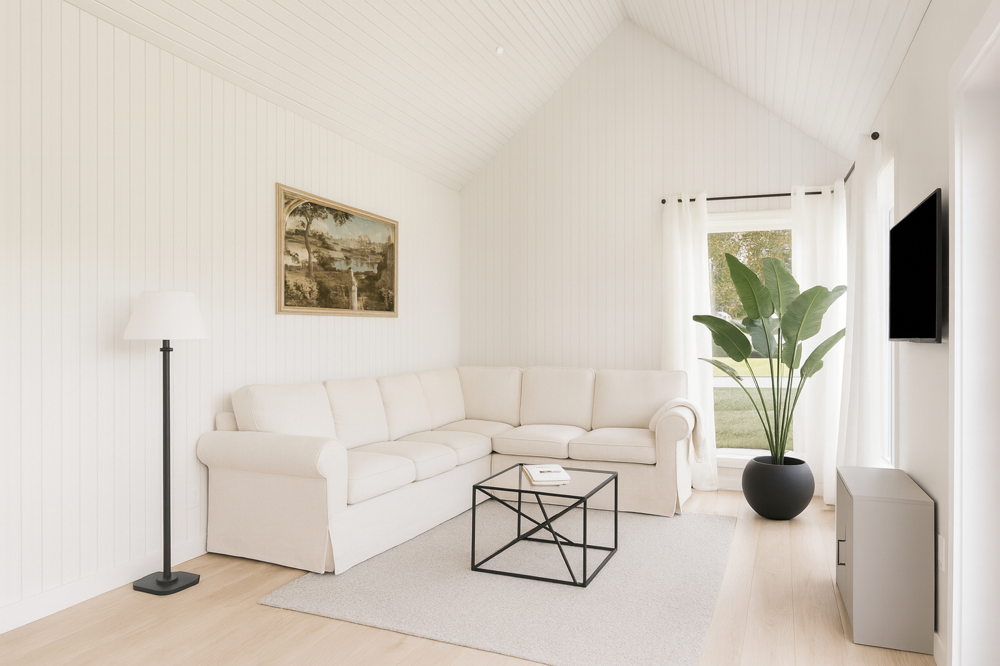
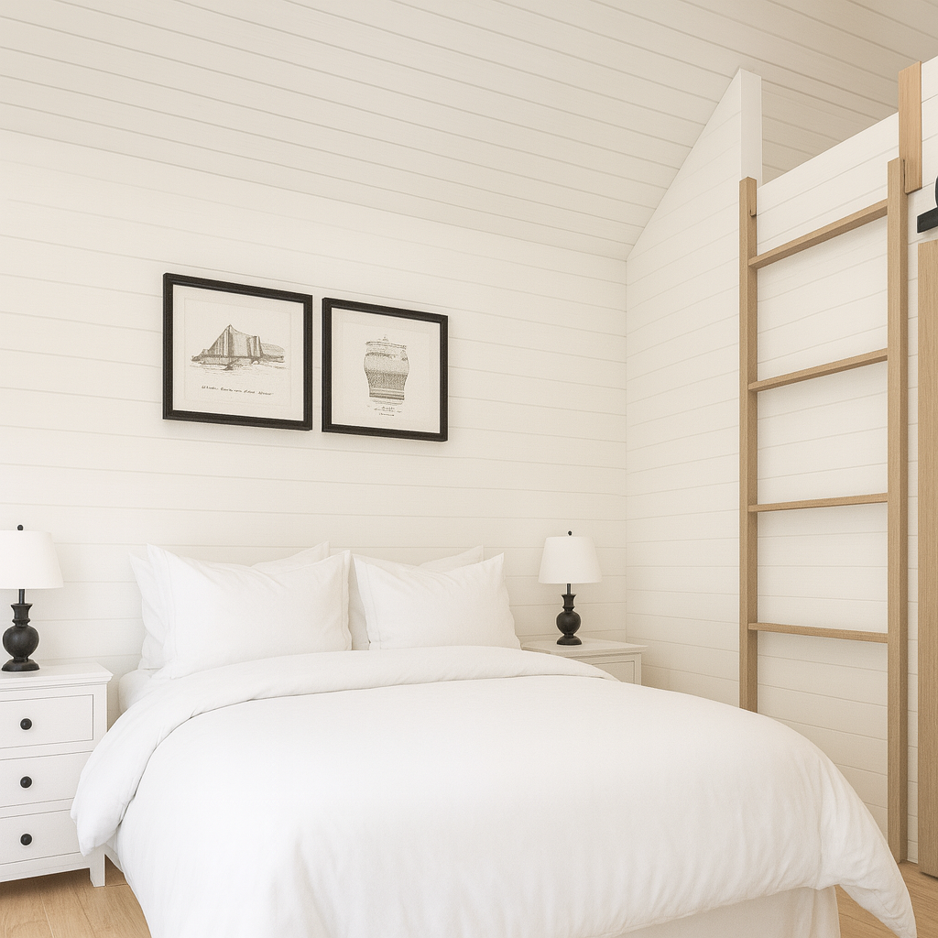
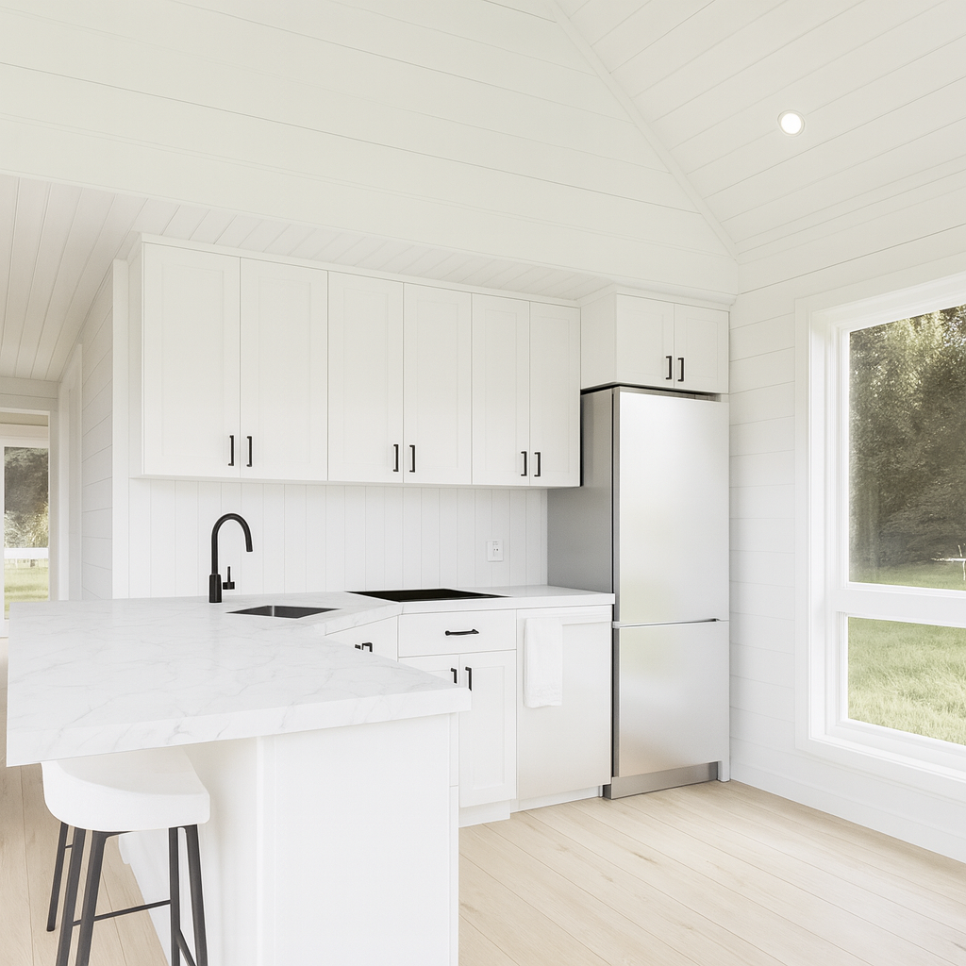
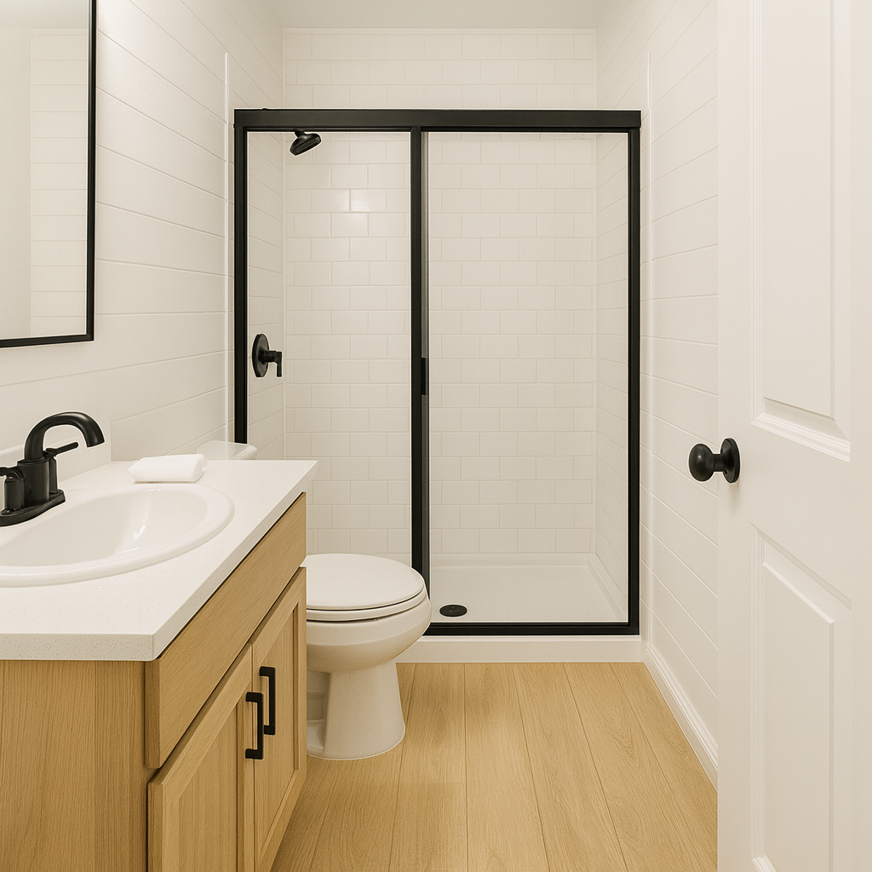

Quotation #: {{quote_number}}
Quotation Date: {{quote_date}}

Customer & Project Information
Field | Details
Customer Name | {{customer_name}}
Email | {{customer_email}}
Phone | {{customer_phone}}
Project Location | {{postal_code}}
Land Status | {{land_status}}
Intended Use | {{intended_use}}
Number of Homes | {{number_of_homes}}
Financing Assistance Needed | {{needs_financing_help}}

Model Specifications
Specification | Details
Model Name | {{model_name}}
Description | {{model_description}}
Square Footage | {{sqft}}
Bedrooms | {{bedrooms}}
Package Selected | {{package_name}}
Estimated Timeline | {{timeline}}

Add-ons & Upgrades
Add-on/Upgrade | Selected | Cost Range
Solar Panels | {{solar_panels}} | $10,000 - $15,000 CAD
Deck | {{deck}} | $8,000 - $10,000 CAD
Upgraded Appliances | {{upgraded_appliances}} | $10,000 - $12,000 CAD
Smart Home Package | {{smart_home_package}} | $4,500 - $5,500 CAD
Fireplace | {{fireplace}} | $5,000 - $8,000 CAD
Off-Grid Package | Coming Soon! | $36,000 - $44,000 CAD

Pricing Breakdown
Add-on/Upgrade | Cost Range
Base Model Price Range* | {{base_model_price_range}}
Package Cost | Coming soon!
Add-ons & Upgrades | {{addons_cost}}
Estimated Price Range | {{estimated_price_range_display}}
*The base model price range is comprehensive—from our premium standard to ultra-luxury upgrades.

Important Pricing Information
- Prices may vary based on market conditions and selected finishes or upgrades
- This estimate includes a buffer for common upgrades and popular selections not priced individually in this quote
- Most clients choose different finishes — no two builds are exactly alike, and we quote accordingly
- Base model is already well-equipped with upgraded features — this is not a bare-bones starting point
- Layouts are fixed per model unless you're building fully custom (which follows a separate process)
- Final pricing is confirmed during your consultation, based on your specific preferences and needs

Terms & Conditions
- Quote Validity: This quote is valid for 30 days from the date issued and subject to change based on material costs and availability.
- Deposit: A deposit will be required to begin the design and permitting process. Amount varies by project scope.
- Timeline: Estimated timelines are subject to permit approval, weather conditions, and material availability.
- Site Preparation: Customer is responsible for site preparation, utilities connections, and obtaining necessary permits unless otherwise specified.
- Changes: Any changes to specifications after contract signing may result in additional costs and timeline adjustments.
- Warranty: All Discovery Homes products come with our comprehensive warranty package. Details provided separately.
- Financing: Financing options available through approved partners. Terms and rates subject to credit approval.
- Force Majeure: Discovery Homes is not liable for delays due to circumstances beyond our control.

This quote represents our best estimate based on the information provided. Final pricing and specifications will be confirmed during detailed consultation and may vary based on your specific site conditions, local code requirements, and final selections.

Book your call now!

